2019 United Methodist Men Spiritual Congress Registration
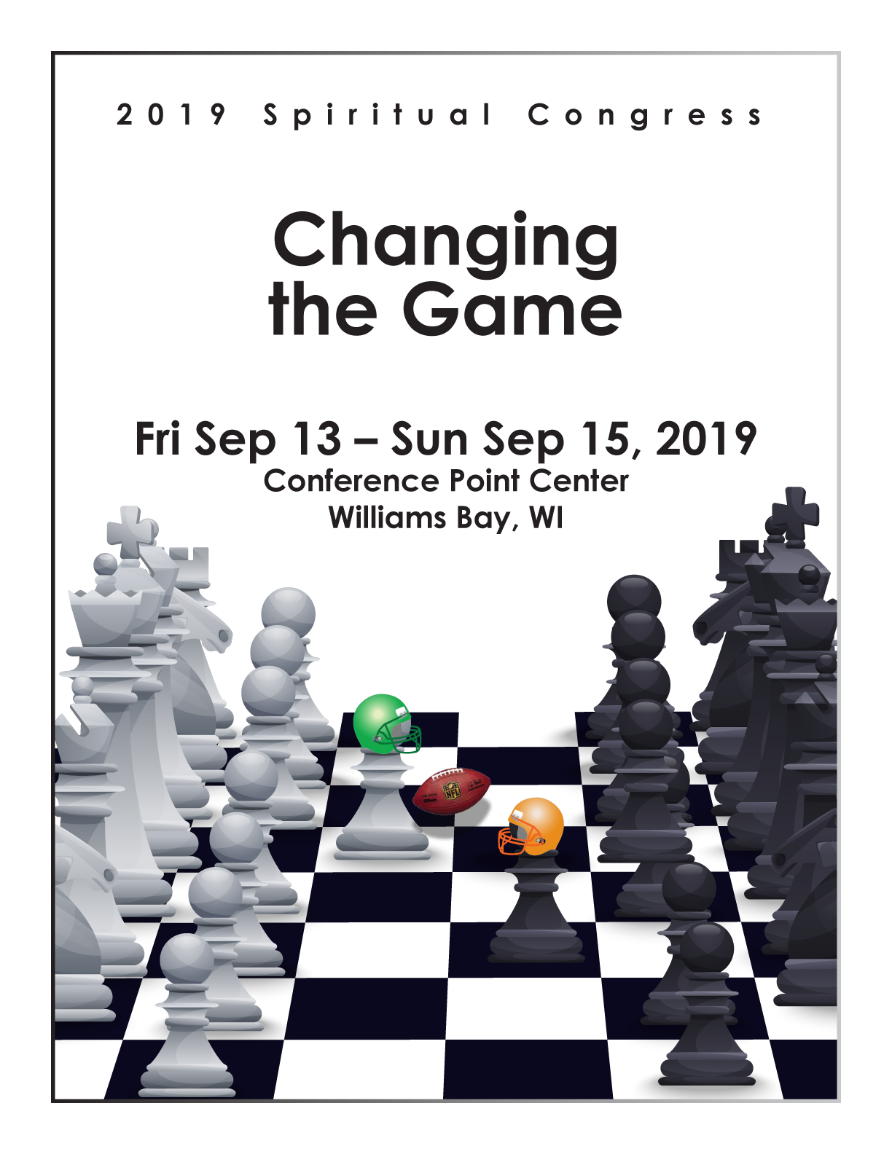

Name:
Address:
City:
State:
Zip:
Phone:
Email:
Local Church:
District:
Attendance | Adult (18 & Under)
Friday-Sunday |  | $175 ($160)
Friday & Saturday |  | $145 ($130)
Saturday & Sunday |  | $145 ($130)
Saturday Only | • | $90 ($85)
Total Amount:
Date:
Check Number:
Make checks payable to NIC-UMM
-'- · I require handicap accessible lodging

, I have special dietary requirements. Please specify:

I WILL HELP WITH THE PRAYER WALL

"'

To register to attend the Northern Illinois Conference 2019 Spiritual Congress, please mail this completed form with your check,

PAYABLE TO NIC-UMM, to:
CRAIG MCGREGOR
12 CENTER DRIVE
OSWEGO, IL 60543
Email: CraigScottMcGregor@gmail.com
Cell Phone: (630) 346-2239

