2026 SAVE THE DATE!
UMM Annual Spiritual Congress
at Conference Point Center, Williams Bay, WI.
Friday, September 11th to Sunday, September 13th
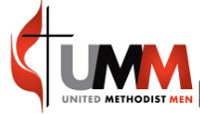

Walking each day with HOPE renews my strength
SOAR ON WINGS LIKE EAGLES
(ISAIAH 40:31)
The Spiritual Congress is an Annual Retreat, sponsored by Northern Illinois Conference United Methodist Men … is a time for learning, fellowship, worship, and relaxation. It is time for Renewal!

For more information and registration: NICUMM.ORG

